Steps to install python in windows pc
- Go to the official website: https://www.python.org
- Click “Downloads”
- Click “Download Python 3.x.x” (latest stable version)
- Run the .exe file
- After pop up
- click install now
- after installing search for windows IDLE and open this python IDLE
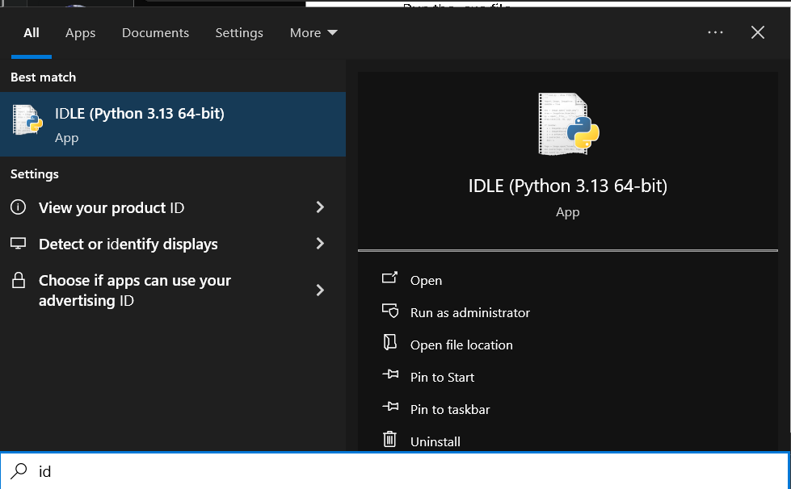

- In the idle click File-> New File
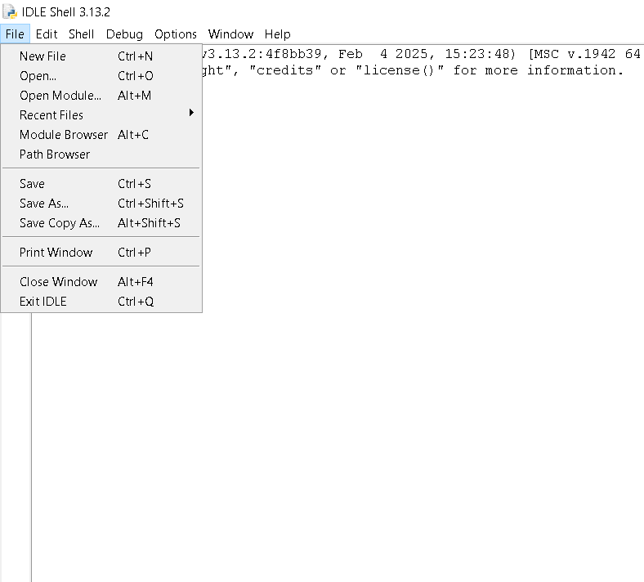
- Write you c code in the New File
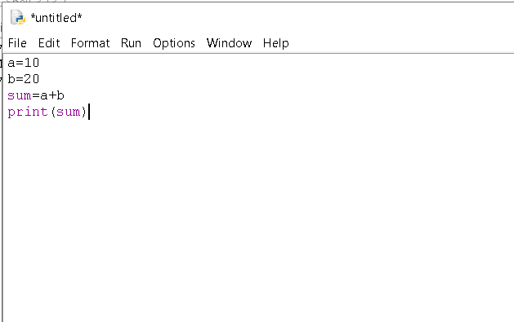
- Save the code file with Ctrl + S
- To run the program click run-> run module
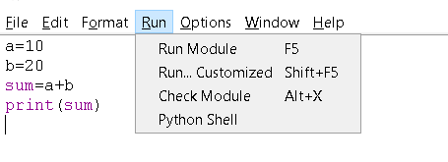
- Output is printed in the shell window

